Why is Balfour School right for my family ?

We believe that Balfour School should be the school of your choice for the following reasons:
Class sizes – We believe that small class sizes make a significant difference to the quality of education able to be delivered. Currently, through additional staffing provided by the community, we have class sizes averaging 17 pupils per classroom.

Academic Achievement – A very high emphasis is placed on academic achievement, with emphasis placed in Literacy and Numeracy, especially in the Junior School.
‘The teacher effectively assesses, plans and teaches reading and writing to meet the learning stages of students’ ERO Report 2009

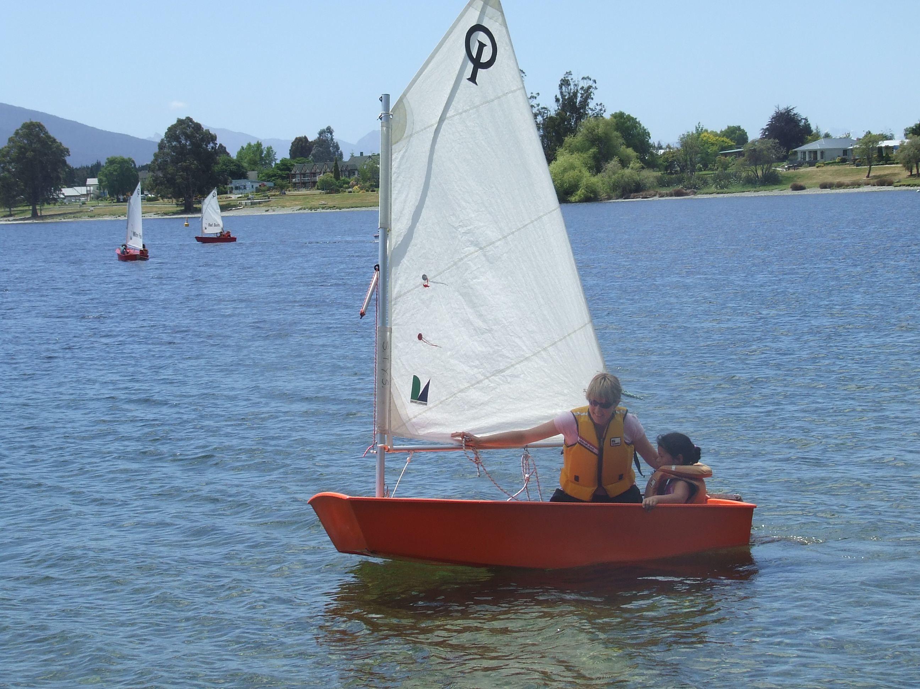

Staffing – We have a dedicated, enthusiastic, gender balanced teaching and support staff who are committed to providing the pupils with the best possible learning environment both within and outside the classroom.
‘Students show high levels of engagement and enjoyment in their learning’ – ERO Report 2009

Innovative, up to date curriculum and teaching methods We continually strive to include innovative teaching methods to inspire our pupils. We are committed to the inquiry learning approach, and use ICT where appropriate to enhance classroom programmes. We have interactive whiteboards in each class and a pod of laptops for pupil use.

Education Outside the Classroom – We have an extensive EOTC programme which includes camps for the two senior classes, and ongoing native reserve and stream monitoring projects.

Sporting Opportunities – Balfour school pupils enjoy a wide range of sporting opportunities both through the School and through local clubs in the area

Pre-School Relationships – The Playcentre has recently relocated to the School site, making the transition to school very smooth.

